Write the following SQL queries. (5 points each)

1. Display a list of all instructors, showing their ID, name, and the number of sections that they have taught. Make sure to show the number of sections as 0 for instructors who have not taught any section. Your query should use an outer join and should not use scalar subqueries.

Answer:

select id,name, count(sec_id) as NumberOfSections

from instructor natural left outer join teaches

group by id,name

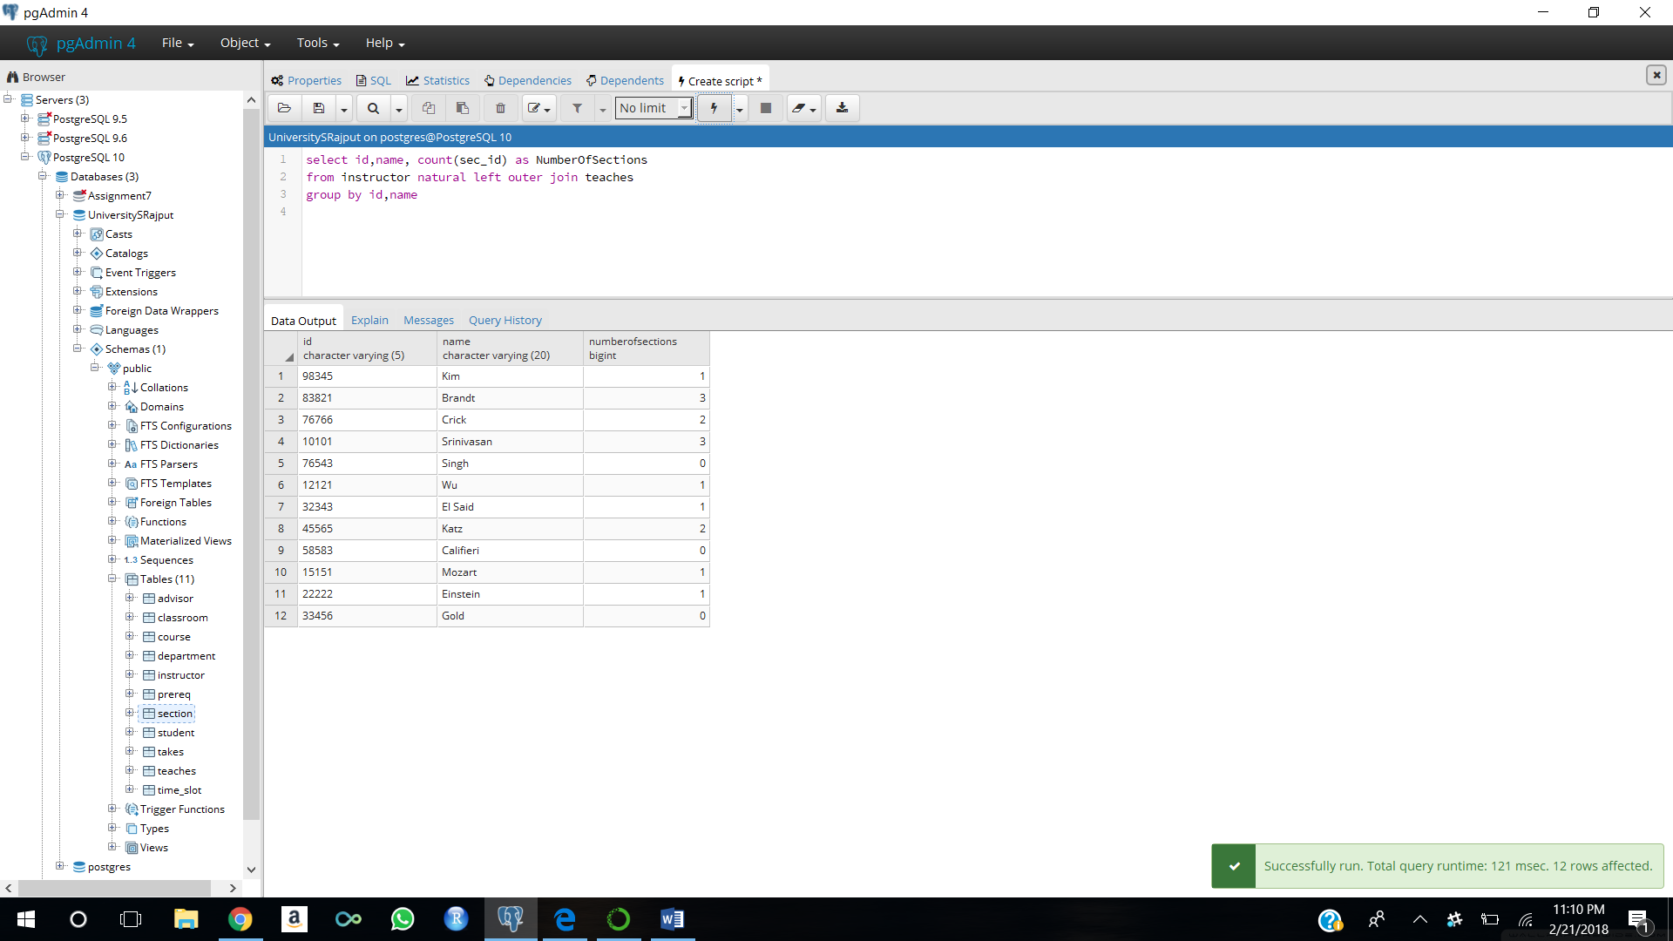

2. Write the same query as above without using join.

Answer:

select id,name, (select count(sec_id) as NumberOfSections

from teaches t where t.id=i.id)

from instructor i

group by id,name

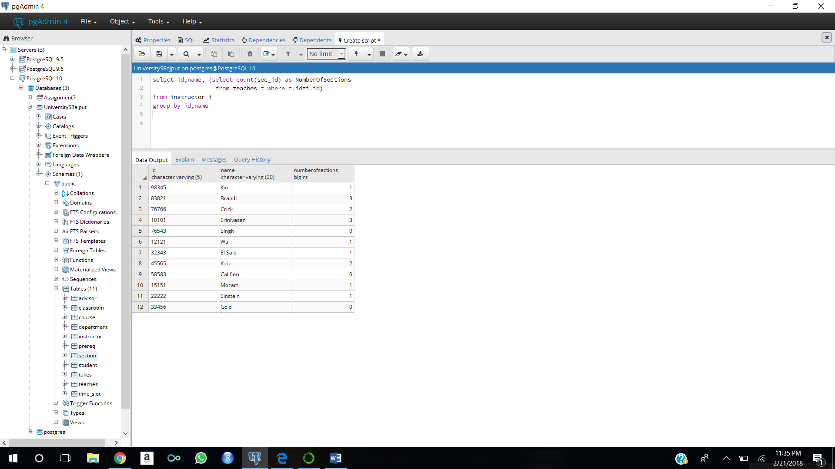

3. Display the list of all departments, with the total number of instructors in each department, without using scalar subqueries. Make sure to correctly handle departments with no instructors. Use a different outer join than you used in the first question

Answer:

select d.dept_name, count(id)

from department d natural right outer join instructor i

group by d.dept_name

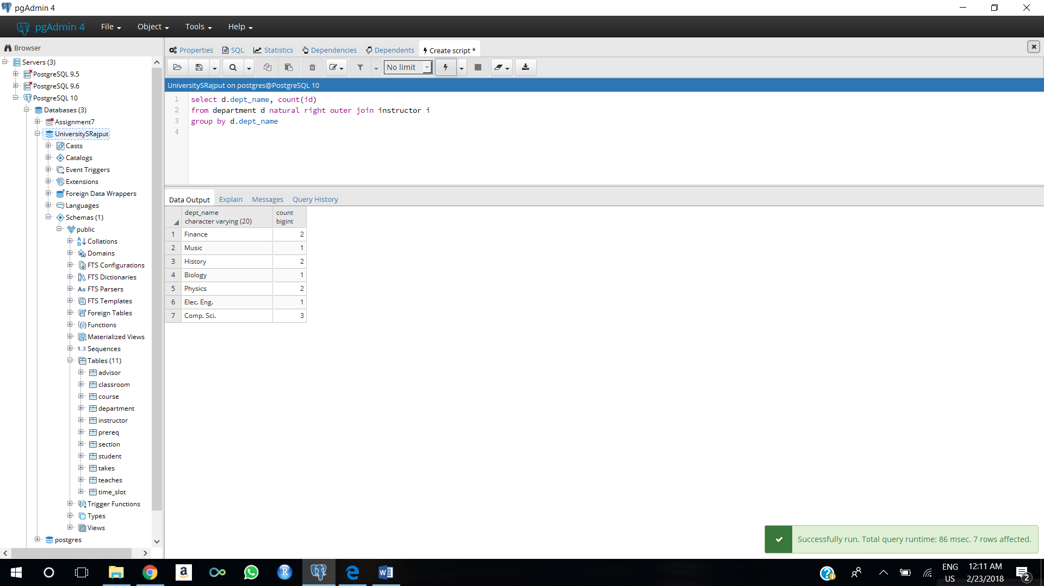

4. Retrieve the names of all instructors who work in the department that has the employee with the highest salary among all instructors.

select i.name

from instructor i

where i.dept_name = (select i.dept_name

from instructor i

where i.salary = (select max(salary) from instructor i))

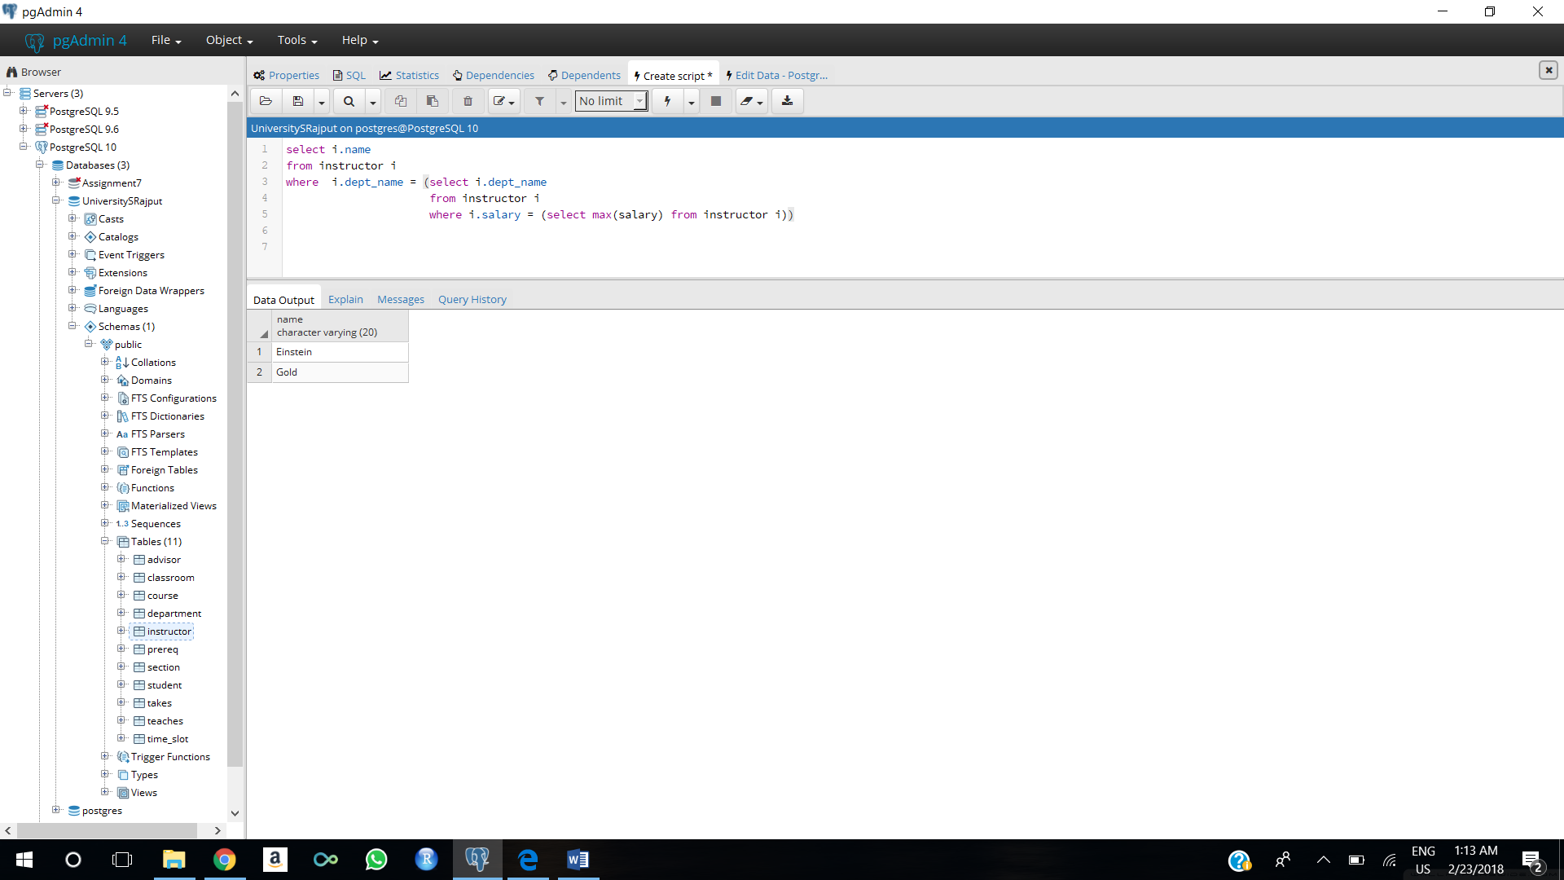

5.Retrieve the names of instructors who make at least $10,000 more than the instructor who is paid the least in the university.

select i.name

from instructor i

where i.salary >= 10000 + (select min(salary)

from instructor)

